**A Squamish veteran in his 102nd year**

**Local Ted Arsenault went to war at 21, in 1942**

Jennifer Thuncher / Squamish Chief

October 28, 2020 10:27 AM/

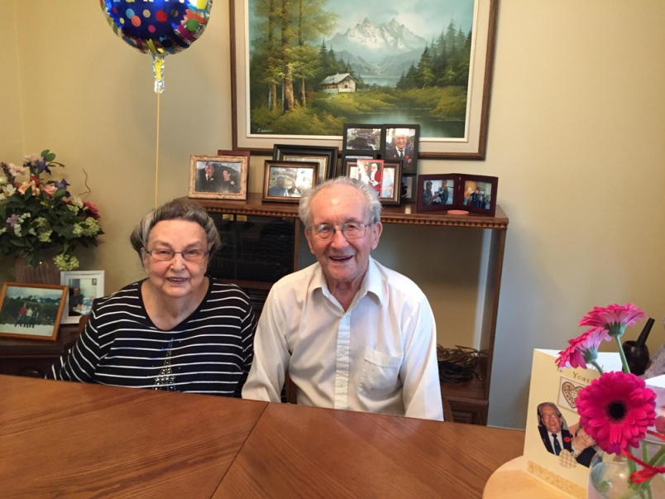

Ted and May Arsenault.

Photo: Courtesy the Arsenault family

When Squamish's Ted Arsenault was about 14 years old, he was driving a dog team of 12 in northern Saskatchewan.

As a boy in the prairies, he had a lot of freedom and ran around barefoot, he said. Not like kids these days.

"We used to have dogs and dog teams — oh, we had a good life," he recalled to The Chief a day before his birthday.

On Oct. 10, Arsenault turned 102.

"I just take it day to day," he said about his many years on the planet. "That is all you can do."

Fellow members of the Squamish Legion — Royal Canadian Legion Branch 277— drove by his home and honked the horn to celebrate the occasion.

His advice for younger folks is to let things work themselves out.

People get too worked up about things, he said.

Arsenault went to war at 21, in 1942. He trained as a gunner and was assigned to the 14th Field Regiment of the Royal Canadian Artillery, which was part of the third Canadian Infantry Division.

After the war, like many soldiers at the time, when he was shipped back to Canada on a troopship, he had a wedding ring on.

His bride Mary (May) came to Canada from Scotland on a different ship.

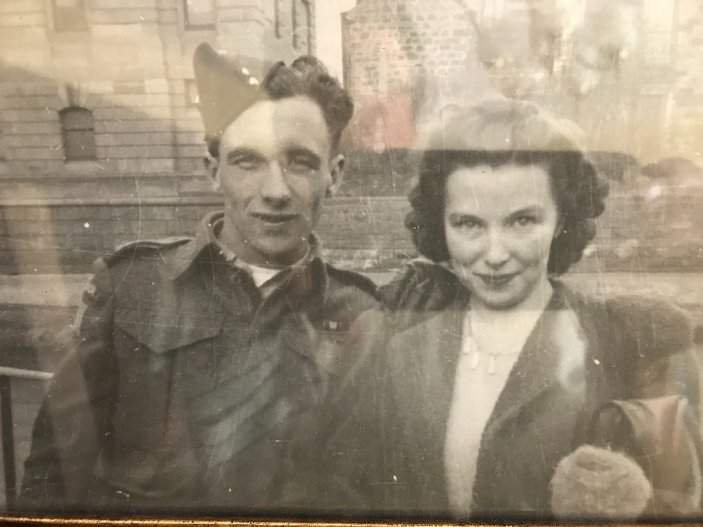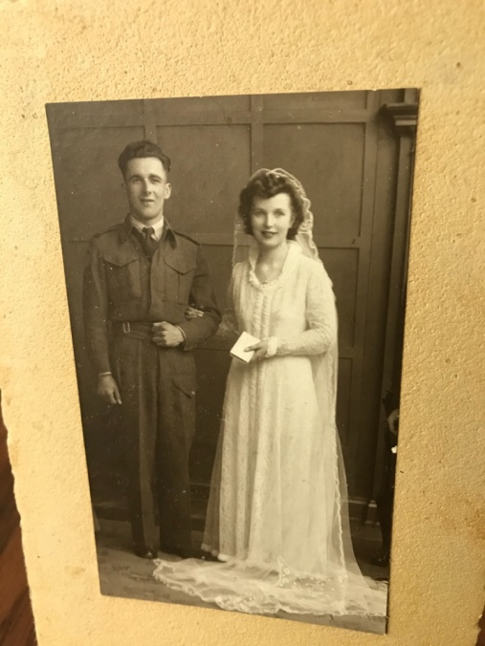

Ted and May. - The Arsenault family

The couple — who met in 1943, when Arsenault was stationed in Scotland — married in 1945 and would go on to have three children: Eileen, Terry and Darryl.

Arsenault became a conservation officer for the Government of Saskatchewan; a job he held for 43 years.

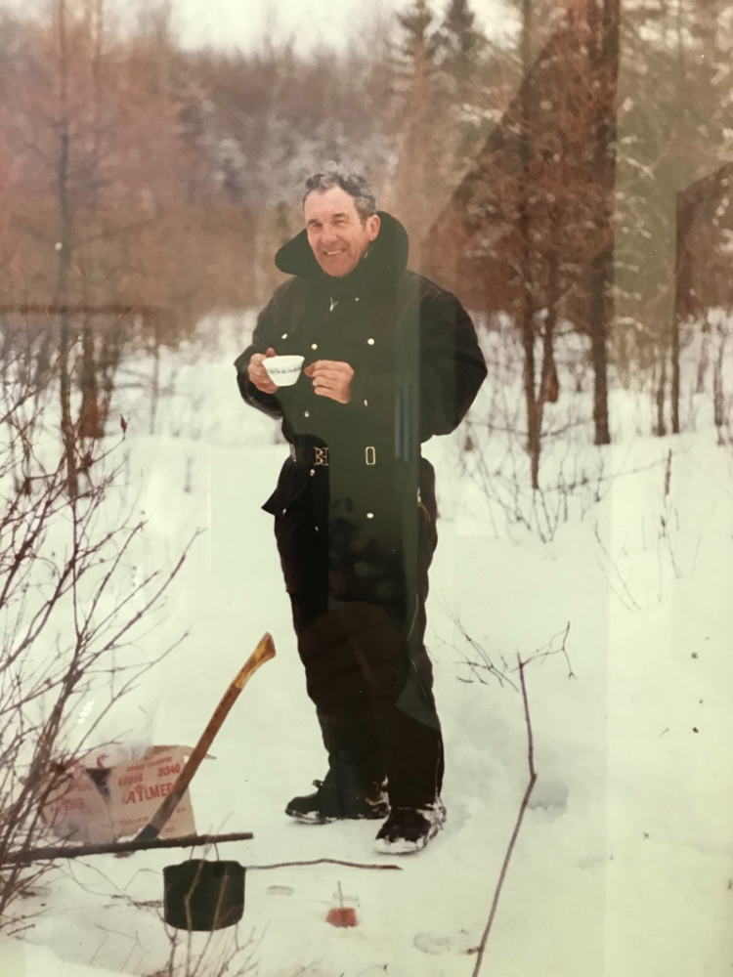

Ted Arsenault as a conservation officer.- The Arsenault family

"That was a good job because it was all about conservation and protection of wildlife, forests, and lakes," said Arsenault in a speech he gave at Howe Sound Secondary in 2013.

When Arsenault retired in 1983, the couple moved to Squamish.

"Squamish is a good place," he told The Chief. "We both like Squamish."

These days, Arsenault said he keeps up with all the current events and has news radio on all day.

"We have to do what we can," Arsenault said about following pandemic protocols.

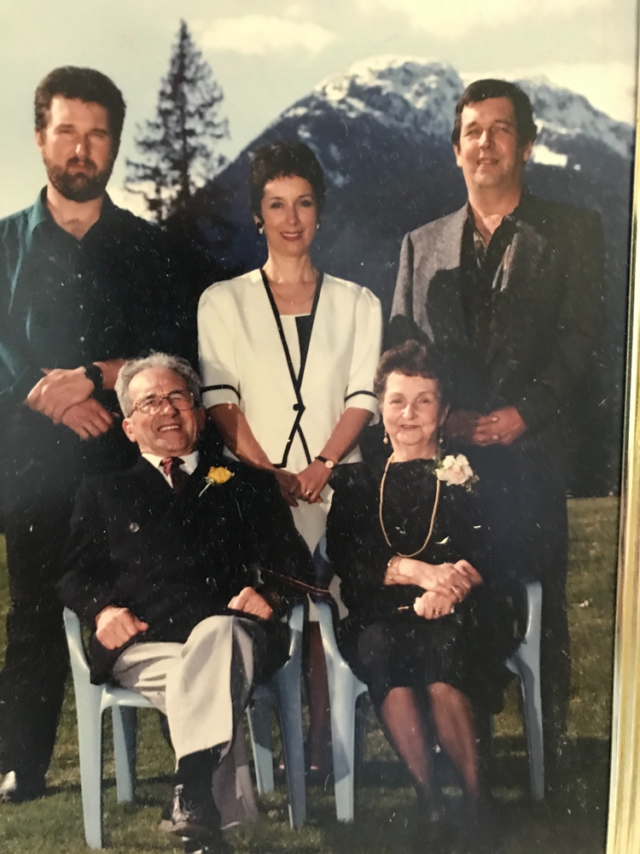

Source: The Arsenault family

**A daughter's memories**

Arsenault's daughter Eileen Walsh says she and her siblings had a "really good childhood," growing up in Northern Saskatchewan.

"An active childhood — kind of out in the woods. It was really an ideal childhood."

Walsh says her dad has always been a "real family man" and took an active interest in his kids' lives.

"Teaching the boys hunting — and all the guy things," she said. "And support for me."

After moving to Squamish, her parents became very involved in seniors' programming in town and started one of the original seniors walking groups, Walsh said.

"Dad was a great winemaker and my mom was always a wonderful baker and cook and they used to take a little bottle of wine out and invite the walkers back for donuts that my mother made," she said.

**In service**

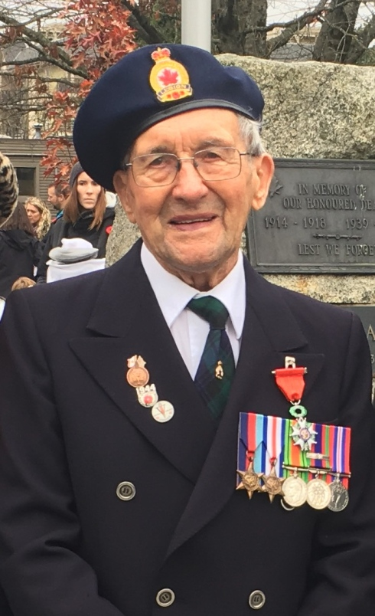

~By Ken Ward

On the day following the D-Day (June 6, 1944) gunner Theodore Arsenault landed at Bernières-sur-Mer in Normandy, France. His group advanced onward to Bernières-sur-Mer.

The 14th Field Regiment (RCA) spent the months of June to August fighting the Germans in Caen.

Heavy fighting and casualties were encountered during the battle of the Falaise Pocket, which took place from August 12 to 24, 1944. Here, several Germans were taken as prisoners of war.

The Liberation of Paris took place on Aug. 25. Arsenault was part of the Battle of Scheldt in the Netherlands that stretched from Oct. 2 to Nov. 8, 1944.

This was the final offensive where the 3rd Canadian Infantry Division was bestowed with their nickname "Water Rats," recognizing the poor conditions of terrain through which they fought.

His group crossed the Seine River and advanced upon the retreating "enemy" from Rouen towards Ypres. They arrived in Germany to be part of the V-E (Victory in Europe) Day on May 8, 1945.

With the war over in Europe, Arsenault volunteered for active duty in the Japanese War. While he was being trained and vaccinated for this service, the war in Japan ended (Sept. 2 1945). Arsenault returned to Canada on the RMS Queen Elizabeth in the fall of 1945. He was discharged on Jan. 7, 1946 in Regina, Saskatchewan.